NAME:VENKATRAMAMOORTHY.G
- Learn the difference between unordered (<ul>) and ordered (<ol>) lists. Create shopping list and steps list.
<ul> = Unordered List (bullets)
<ol> = Ordered List (numbers or alphabet)
Example:
<ul>
<li>Milk</li>
<li>Bread</li>
<li>Eggs</li>
</ul>

<ol>
<li>Wake up</li>
<li>Brush teeth</li>
<li>Go to school</li>
</ol>
Output:
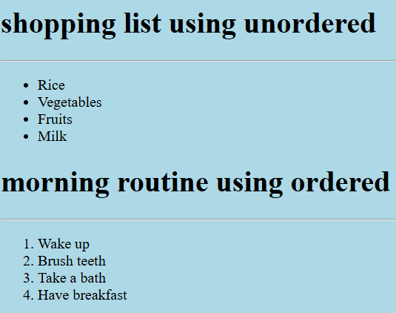
- Practice using <li> inside <ul> and <ol>. Create nested lists (list inside another list).
CODE:
<h1>Shopping List with Categories</h1>
<ul>
<li>Fruits
<ul>
<li>Apple</li>
<li>Banana</li>
</ul>
</li>
<li>Vegetables
<ul>
<li>Carrot</li>
<li>Potato</li>
</ul>
</li>
</ul>
OUTPUT:
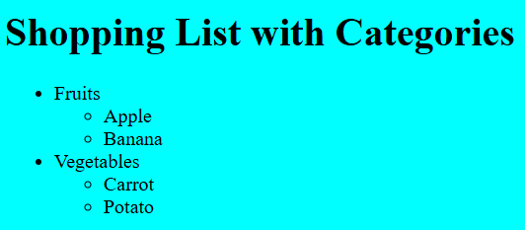
- Learn the structure of tables. Create a simple table with rows and columns.
A table uses:
- <table> = main container
- <tr> = table row
- <th> = table header
- <td> = table data
Code:
<table>
<tr>
<td>Name</td>
<td>Age</td>
</tr>
<tr>
<td>alice</td>
<td>22</td>
</tr>
</table>
Output:
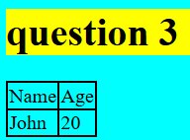
- Add headers to tables using <th>. Compare difference between <td> and <th>.
Tag | Purpose | Appearance
<th> | Table header | Bold,center
<td> | Table data | Normal text

Example:
<table>
<tr>
<th>Name</th>
<th>Age</th>
</tr>
<tr>
<td>Alice</td>
<td>22</td>
</tr>
</table>
Output:
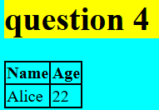

- Practice table attributes: colspan, rowspan, and add borders, cell spacing, and padding with CSS.
Link [ https://github.com/GVRaman17/task/tree/cf2577356d31a487187324960d0d45f5ffe2aa06/18-03-2026%20html%20task%207]
